**Milestone 4: Purchases**

Activity 1: Purchase Order Creation

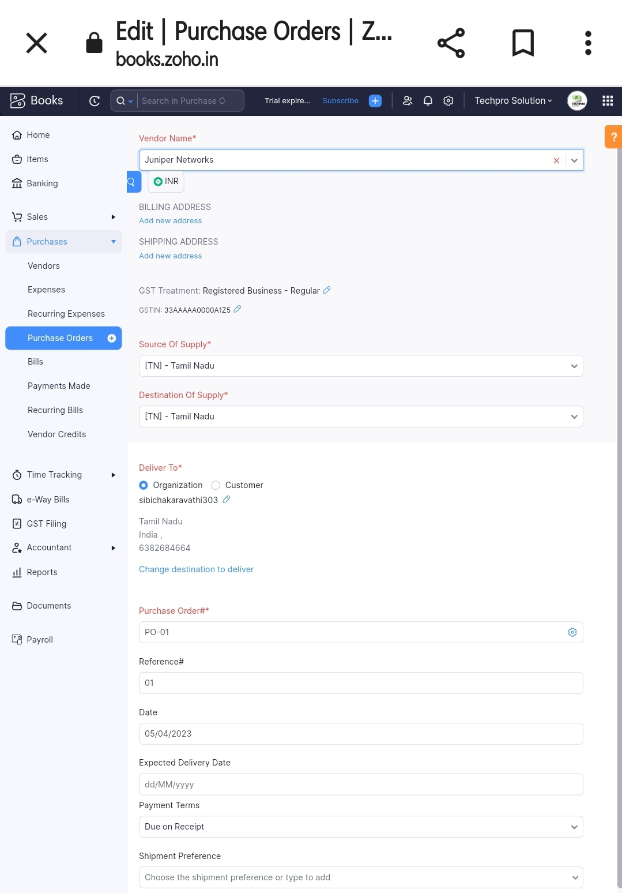

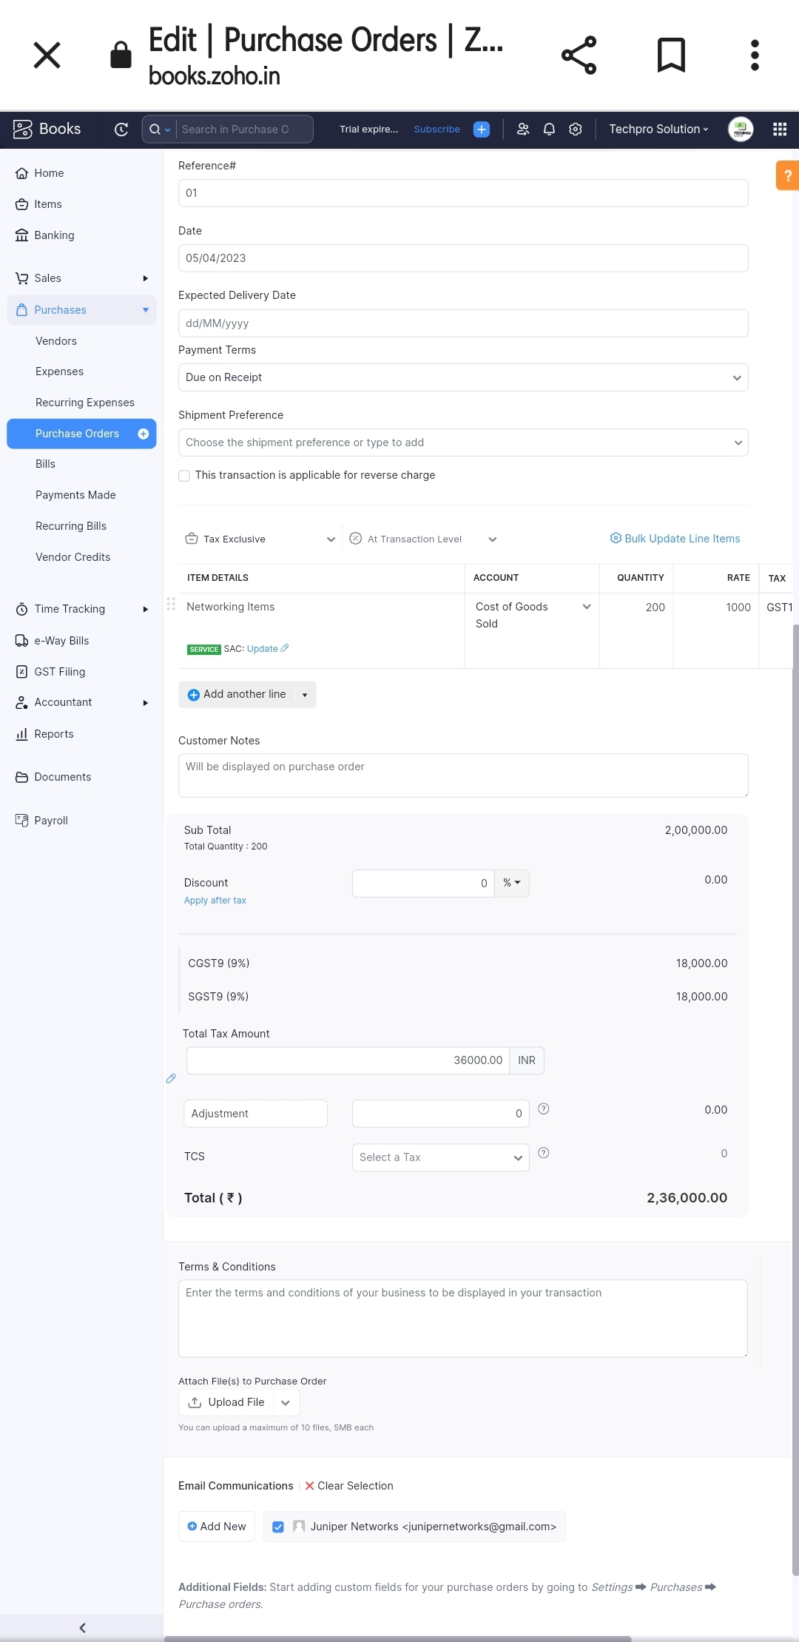

Activity 2: Purchase Order to Purchase Bill Convertion

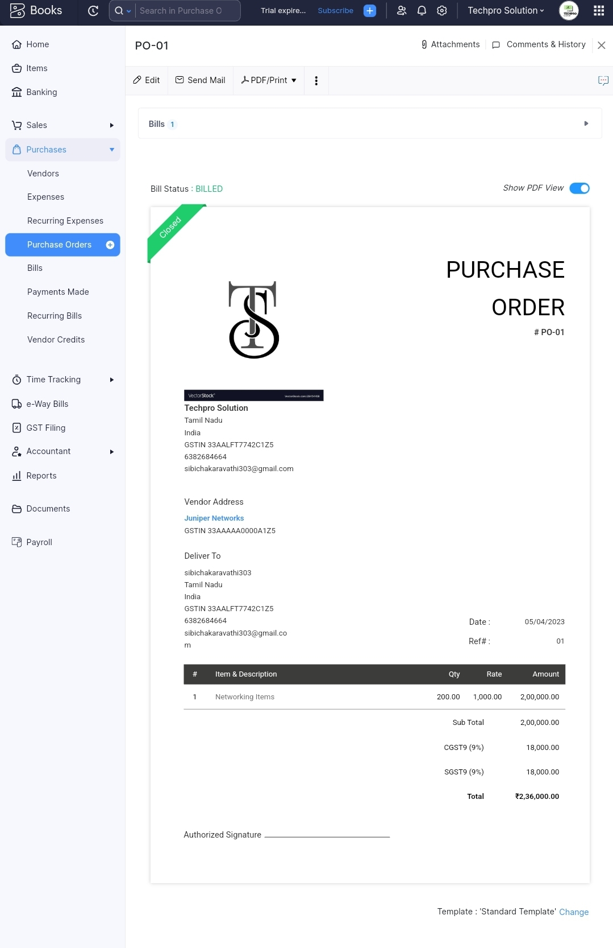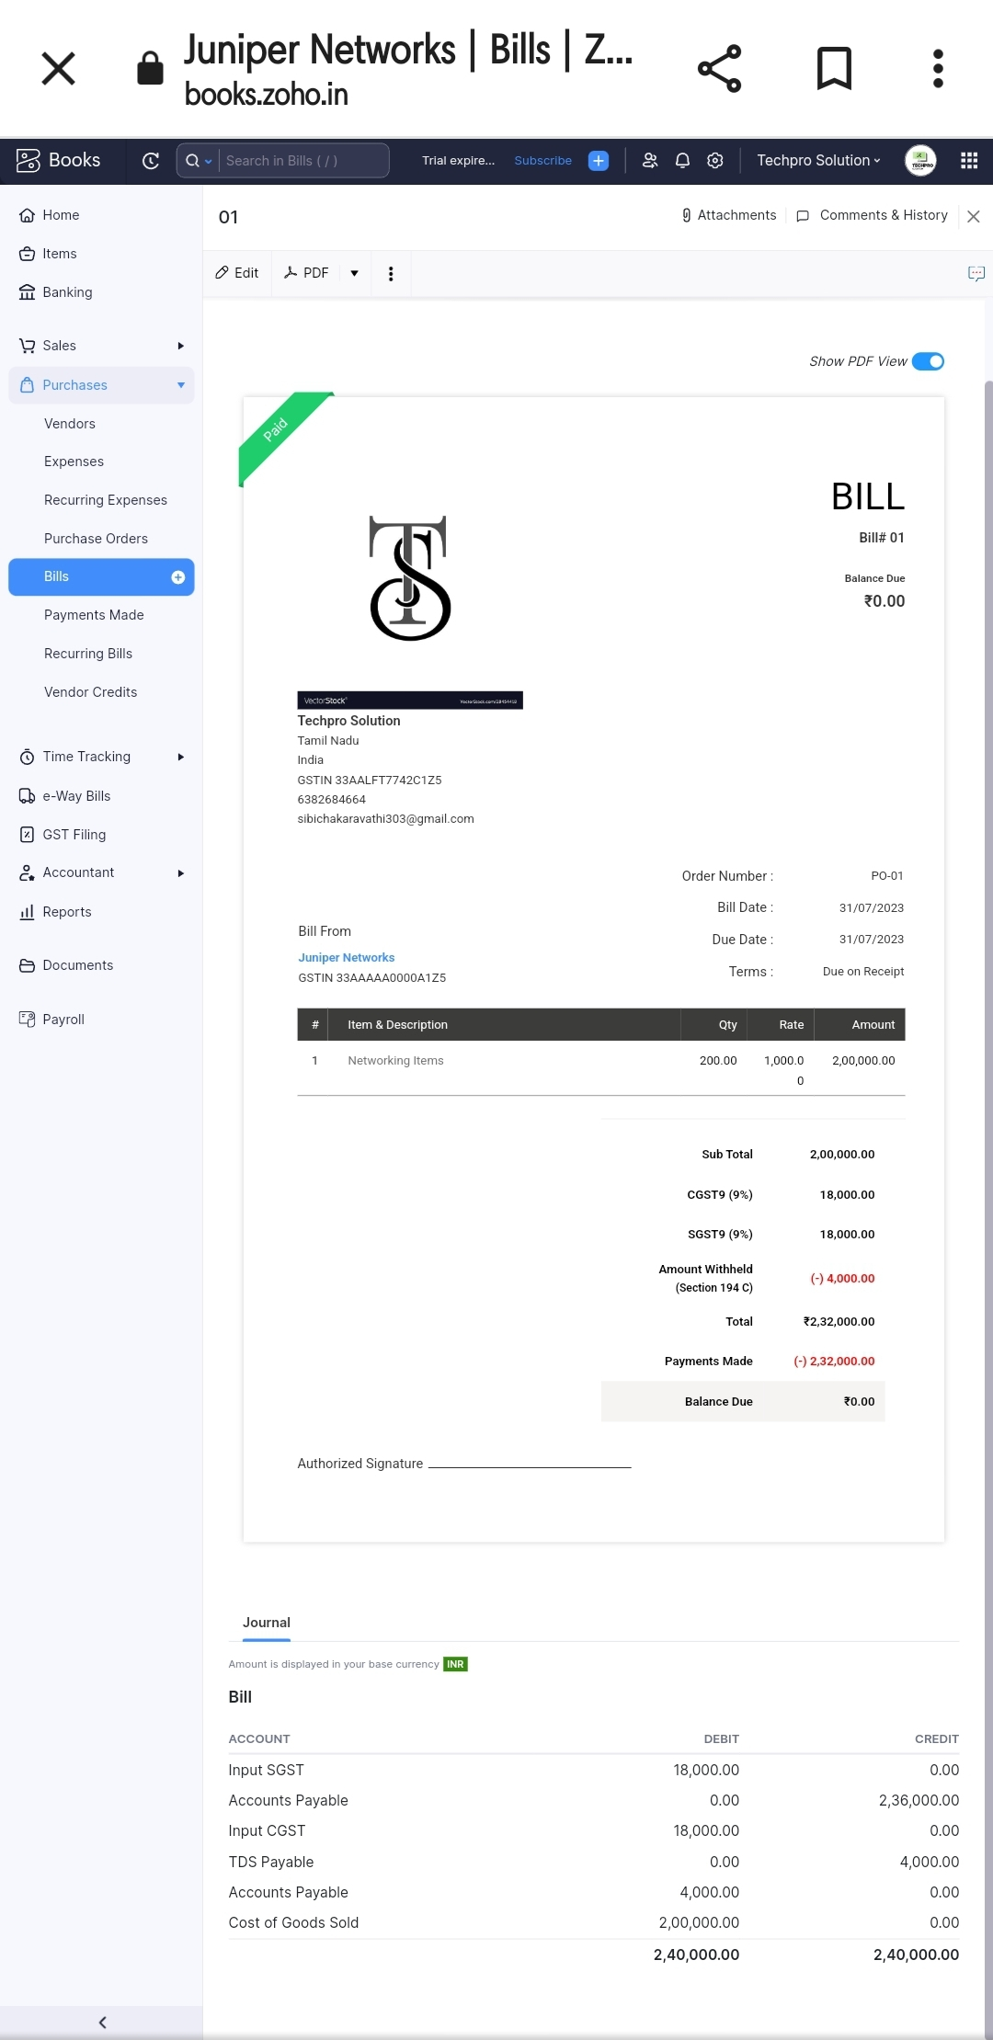

Activity 3: Direct Vendor Purchase Bills Creation

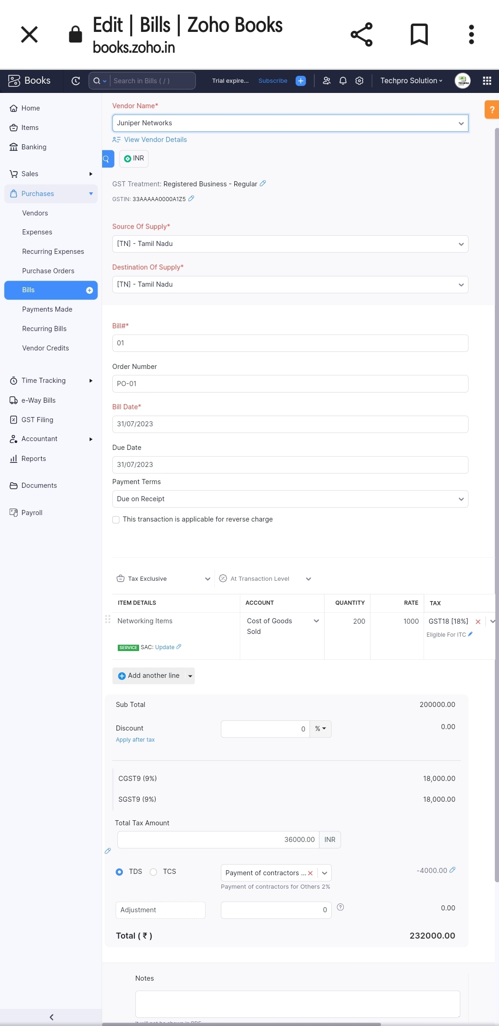

Activity 4: Reconciliation of Open & Outstanding Bills